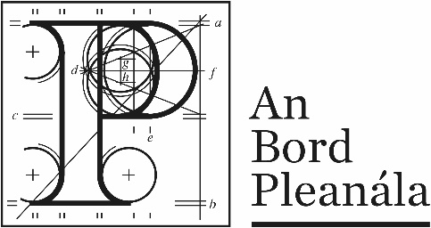
Documents received at Oral Hearing for
ABP-314232-22

Case Description | DART+ West Railway Order - Dublin City to Maynooth and M3 Parkway County Dublin, County Meath, County Kildare
Date | 11th October, 2023
Location | The Gresham Hotel, 23 O’Connell Street Upper, North City, Dublin, D01 C3W7

Documents received at Oral Hearing
No. | Submitted by | Presenter | Topic
 | Tom Phillips – Carlos Clark | Tom Phillips | Module F  Depot  1.168 slides  2. Images Submitted  3. Flood Studies Update
 | William J. Smith | William J. Smith | Module F  Depot
 | Seamus Ross | Seamus Ross | Module E  Ross Owned Lands at Barberstown
 | Alanna Homes | Oisín Collins | Module D
 | Applicant – Slides from day before |  | Footbridge Examples - from 10th Oct 23
 | Applicant | Mark Kilcullen | 9 Sheets Permanent Way Design
 | Applicant |  | Design Standards  2 pages
 | Applicant – Docs submitted at end of the day | Avril Challoner | Air Quality
 | Applicant |  | Updates to Ch 08 Biodiversity
 | Applicant |  | Update Report to the Natura Impact Statement
 | Applicant |  | Updates to EIAR Ch26 Cumulative Effects
 | Applicant |  | Proposed Preservation AH04 Method Statement

